
Foundation University Islamabad
School of Science and Technology

Name: Hunaina Yasir Roll Number: 073
Subject: Oops Lab Section: B
LAB REPORT NO. 1

EXERCISE LAB 7:
TASK 1
Write a class Book with three data members BooklD, Pages and Price. It also contains the following member function:
• The get() function is used to input values
• The show() function is used to display values
• The set() function is used to set the values of data members using parameters
• The getprice() function is used to return the value of Price.
The program should create two objects of the class and input values for these objects. The program displays the details of the costliest book.

SOURCE CODE:
#include <iostream>
using namespace std;

class Book
{
int BookID, Pages;
float Price;

public:
void get()
{
cin >> BookID >> Pages >> Price;
}

void show()
{
cout << "Book ID: " << BookID << endl;
cout << "Pages: " << Pages << endl;
cout << "Price: " << Price << endl;
}

void set(int id, int p, float pr)
{
BookID = id;
Pages = p;
Price = pr;
}

float getprice()
{
return Price;
}
};

int main()
{
Book b1, b2;

b1.get();
b2.get();

if (b1.getprice() > b2.getprice())
b1.show();
else
b2.show();

return 0;
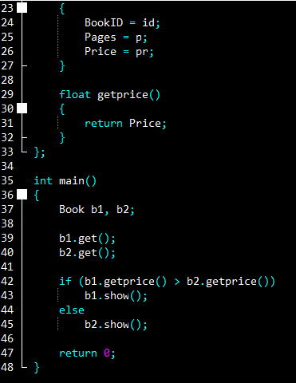
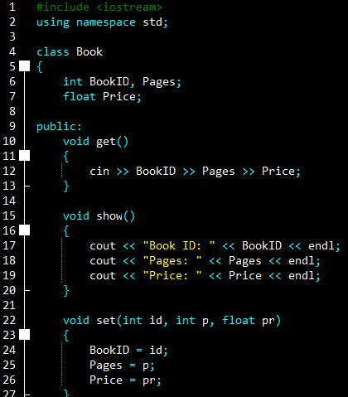
}
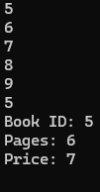
OUTPUT:
5
6
7
8
9
5
Book ID: 5
Pages: 6
Price: 7

TASK 2:
Write a class Reult that contains roll number, name and marks of three subjects. The marks are in an array Of integers, The Class also contains the following member functions:
• The input() function used to input the values in data members.
• The show() function is used to displays the value of data members.
• The total() function returns the total marks a student.
• The avg0 function returns the average marks of a student. The program should create an object of the class and call the member functions.

SOURCE CODE:

#include <iostream>
using namespace std;

class Result
{
int roll;
string name;
int marks[3];

public:
void input()
{
cin >> roll >> name;
for (int i = 0; i < 3; i++)
cin >> marks[i];
}

void show()
{
cout << "Roll: " << roll << endl;
cout << "Name: " << name << endl;
cout << "Marks: ";
for (int i = 0; i < 3; i++)
cout << marks[i] << " ";
cout << endl;
}

int total()
{
return marks[0] + marks[1] + marks[2];
}

float avg()
{
return total() / 3.0;
}
};

int main()
{
Result r;
r.input();
r.show();
cout << "Total: " << r.total() << endl;
cout << "Average: " << r.avg() << endl;
return 0;
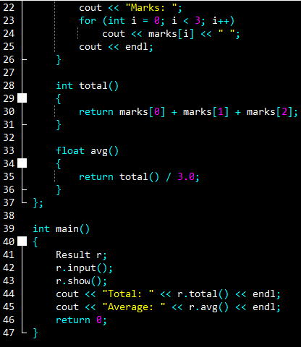
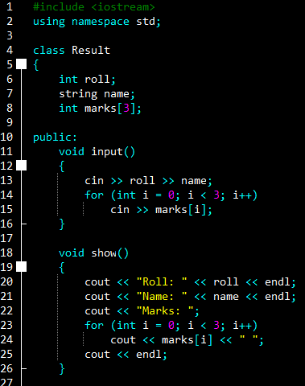
}

OUTPUT:
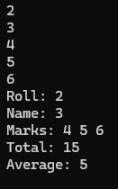
2
3
4
5
6
Roll: 2
Name: 3
Marks: 4 5 6
Total: 15
Average: 5

TASK 3:
Write a class List that contains an array of integers to store five values. It also contains the following member:
• The fill() function is used to fill the array with values from the user.
• The display() function is used to display the values of array.
• The max() function shows the maximum value in the array.
• The min() function shows the minimum value in the array. All member function should be defined outside.
SOURCE CODE:
#include <iostream>
using namespace std;
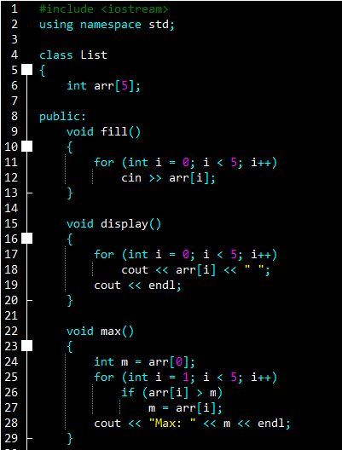
class List
{
int arr[5];

public:
void fill()
{
for (int i = 0; i < 5; i++)
cin >> arr[i];
}

void display()
{
for (int i = 0; i < 5; i++)
cout << arr[i] << " ";
cout << endl;
}

void max()
{
int m = arr[0];
for (int i = 1; i < 5; i++)
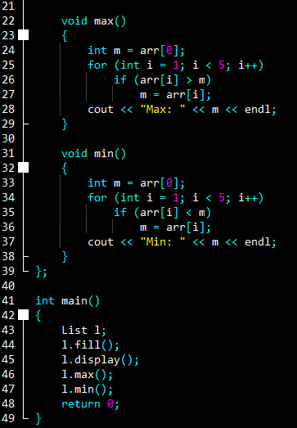
if (arr[i] > m)
m = arr[i];
cout << "Max: " << m << endl;
}

void min()
{
int m = arr[0];
for (int i = 1; i < 5; i++)
if (arr[i] < m)
m = arr[i];
cout << "Min: " << m << endl;
}
};

int main()
{
List l;
l.fill();
l.display();
l.max();
l.min();
return 0;
}

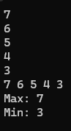
OUTPUT:
7
6
5
4
3
7 6 5 4 3
Max: 7
Min: 3

TASK 4:
Write a class that contains two integer data members which are initialized to 100 when an object is created (using default constructor). It has a member function avg that displays the average of data members.
SOURCE CODE:
#include <iostream>
using namespace std;

class Sample
{
int a, b;

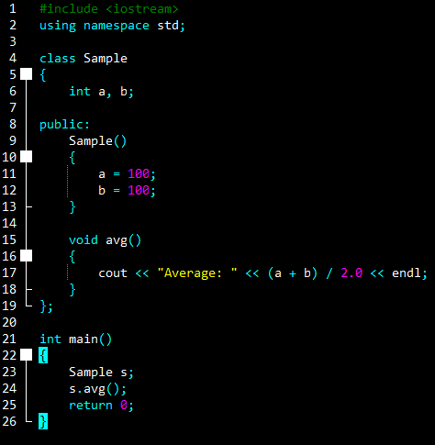
public:
Sample()
{
a = 100;
b = 100;
}

void avg()
{
cout << "Average: " << (a + b) / 2.0 << endl;
}
};

int main()
{
Sample s;
s.avg();
return 0;
}

OUTPUT:
Average: 100

TASK 5:
Write a class TV that contains attributes of Brand Name, Model and Retail Price. Write a method to display all attributes and a method to change the attributes. Also write a constructor to initialize all the attributes (use parameterized constructor). Also release the memory using a destructor function.

SOURCE CODE:
#include <iostream>
using namespace std;

class TV
{
string brand;
string model;
float price;

public:
TV(string b, string m, float p)
{
brand = b;
model = m;
price = p;
}

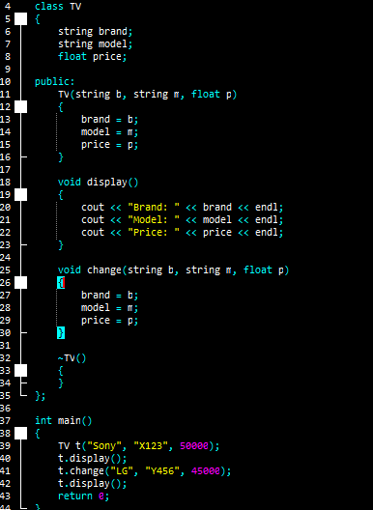
void display()
{
cout << "Brand: " << brand << endl;
cout << "Model: " << model << endl;
cout << "Price: " << price << endl;
}

void change(string b, string m, float p)
{
brand = b;
model = m;
price = p;
}

~TV()
{
}
};

int main()
{
TV t("Sony", "X123", 50000);
t.display();
t.change("LG", "Y456", 45000);
t.display();
return 0;
}

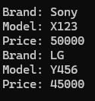
OUTPUT:
Brand: Sony
Model: X123
Price: 50000
Brand: LG
Model: Y456
Price: 45000

